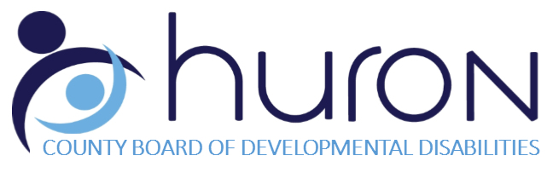

INTAKE DOCUMENTS

Name: ___________________________________________________ DOB: __________________________

Please provide copies of the documents highlighted below to:

Barbara Wrabel, Community Outreach Specialist
Huron County Board of DD
306 South Norwalk Road West
Norwalk, OH 44857

*These are required before county board services can start, if the person named above is found to be eligible.

YES | NO | N/A | Documents Required
x |  |  | Application for Eligibility and Services (included with this form; please complete)
x |  |  | Social Security Card
x |  |  | Birth Certificate
 |  |  | Ohio ID Card (if applicable)
x |  |  | Medicaid Card/Medicare Card/ Private Health Insurance Card
 |  |  | Guardianship Documentation (if applicable)
 |  |  | Other:

